Name: Trinadha Raji Muppala

Class Id: 32

**Introductio**n: Text classification using CNN,RNN,LSTM

**Objectives:** Use Amazon baby products review data, crated rating 5,4 as positive and rating 1,2 as negative, implement text classification using CNN,RNN,LSTM

**Approaches/Methods**:

1. Use Amazon review data, use rating 4,5 data as positive and 1,2 rating as negative.

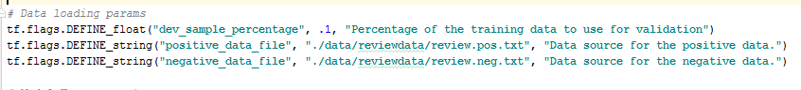

1. Define hyper parameters epochs, batch size, dropout, learning rate

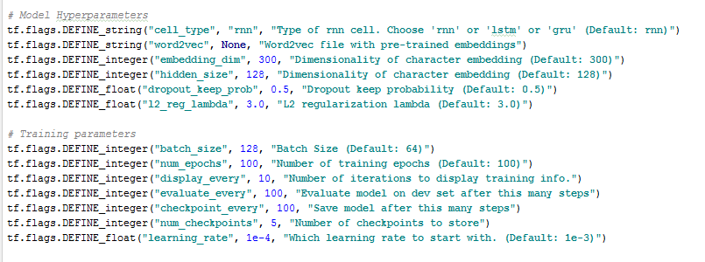

1. Define weight, bias. Define loss, accuracy.

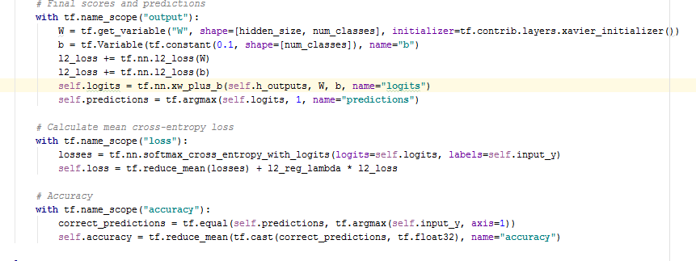

4. Define CNN. Define activation , max pool , optimizer for CNN

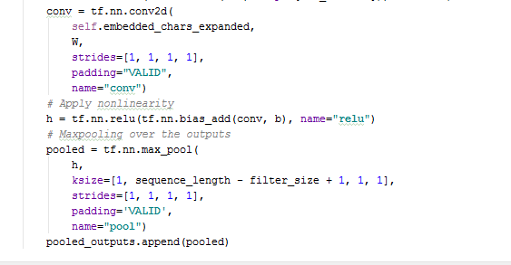



5. Build CNN model , minimize loss and findout accuracy



6. Define RNN or LSTM

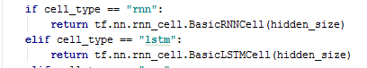

7. Build RNN/LSTM Model minimize loss, find out accuracy

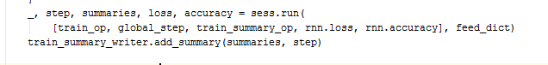

7. Test Mode

**WorkFlow:**

Define Cross entropy reduce loss

Define place holders, weight , strides, activation function(cnn), max pooling(cnn)

Divide data train test

Read Data

Train CNN/RNN/LSTM model for the epochs, with batch size and learning rate

Set hyper parameters (learning rate, batch size, epochs, dropout)

Find training and testing accuracy

**Data Sets: Amazon baby review data, Defined 2 classifications positive and negative. Divided summary for rating 4,5 as positive and 1,2 rating as negative**

<https://www.kaggle.com/roopalik/amazon-baby-dataset/data>

review.pos.txt

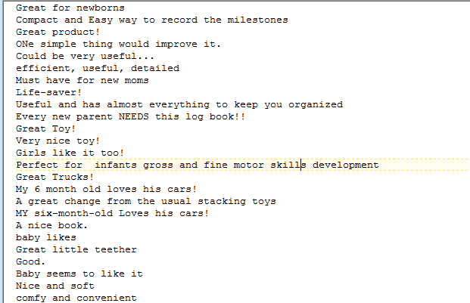

Review.neg.txt

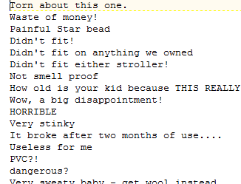

**Parameters:**

**Activation function** – ReLu , **Pooling** – Maximum pooling

**Evaluation and Discussion:**

Trained with learning rate with 0.01

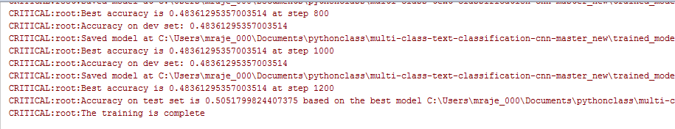

Learning rate 0.03

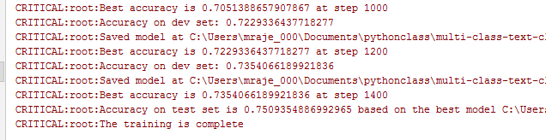

**Conclusion:**

Learning rate with 0.03 improved accuracy to 0.75

**TensorBoard:**

